## 

***Requirements Definition***

***Document***

Prepared By: Isaac Duah-Acheampong

Organization: Team Platypus ( Team 5)

Date:2/27/2020

Version: *1*

**INTRODUCTION**

The Requirements Definition Document outlines the scope, and resource requirements for the implementation of the Penetration Liability Assessment Tool, Your Prices Updating Security(P.L.A.T.Y.P.U.S)***.*** This report provides the information necessary to support the High Level Scope and Sizing and defines the P.L.A.T.Y.P.U.Sproject in sufficient detail to support the future Design Phase.

This Requirements Definition Document was developed jointly by Team 5 and development teamDepartment and is based on information gathered from discussions with key system users, financial and management. It provides a summary of information gathered to date and is organized into the following chapters:

**Executive Summary**

Summarizes the P.L.A.T.Y.P.U.Sproject and system scope and highlights the significant points discussed in the remaining chapters.

**Business Requirements and Rules**

Specifies the problem, current processes, and proposed business solution.

**Functional Requirements**

Describes the key functions and features of the proposed system. Identifies the type of information the system will provide.

**Interface Requirements**

Details the hardware and software requirements and details the necessary interfaces required.

**Operational and Performance Requirements**

Examines operational, availability, facility, infrastructure, network and security requirements necessary to support the development and installation of P.L.A.T.Y.P.U.S.

**User Acceptance Testing Requirements**

Outlines the approach and environment necessary for the effective testing and assurance of operational readiness prior to implementation commencement.

**Implementation Requirements**

Presents the implementation requirements, training requirements, major milestones and resource requirements.

**Business Area Impacts**

Presents a chart of areas of the business impacted by this implementation and the personal representatives of each area.

**Appendices**

Documents additional (PROJECT NAME) related information. This section contains a glossary of key terms used in the report, and key assumptions used to estimate the resource requirements of the project, and the current project plan.

**TABLE OF CONTENTS**

**1** **EXECUTIVE SUMMARY 1**

1.1 Introduction 1

1.2 P.L.A.T.Y.P.U.S System Overview 1

1.3 P.L.A.T.Y.P.U.SProject Overview 1

**2** **BUSINESS OBJECTIVES 2**

2.1 Introduction 2

2.2 Overview 2

2.3 Corporate Goals 2

2.4 Statement of Business Objectives 2

2.5 Current Process 3

2.6 Proposed Solution 5

**3** **BUSINESS REQUIREMENTS 8**

3.1 P.L.A.T.Y.P.U.S Business Functions 8

3.2 P.L.A.T.Y.P.U.S Maintenance Functions 8

3.3 Report Requirements 8

**4** **TECHNICAL REQUIREMENTS 9**

4.1 Hardware and System Software Requirements 9

4.2 Software System Interface Requirements 9

4.3 Commercial off-the-shelf Software 9

**5** **OPERATIONAL AND PERFORMANCE REQUIREMENTS 10**

5.1 Operation Mode and Availability 10

5.2 Capacity Requirements 10

5.3 Storage Requirements 11

5.4 Facility, Co-location, Infrastructure, or Co-hosting Requirements 11

5.5 Network or Connectivity Requirements 11

5.6 Security Requirements 11

5.7 Post-Implementation Support Concepts 11

**6** **USER ACCEPTANCE TESTING REQUIREMENTS 12**

6.1 Categorize the Business Requirements into testing priorities and risk factors. 12

6.2 Identify UAT Scenarios, test cases and test conditions. 12

6.3 User Acceptance Test Approach 12

6.4 User Acceptance Test Environment 12

**7** **IMPLEMENTATION REQUIREMENTS 13**

7.1 Introduction 13

7.2 Training Requirements 13

7.3 System Roll Out Requirements 13

7.4 Communications Requirements 13

7.5 Operational Procedures 13

7.6 User Documentation Requirements 13

7.7 System Distribution Requirements 13

7.8 Facility Readiness Requirements 13

7.9 Built-in Help Requirements 13

**8** **GLOSSARY OF TERMS 14**

REQUIREMENTS DOCUMENT APPROVALS

|  |  |
| --- | --- |
| **APPROVALS** | |
| **Project Sponsor:** Ronald Dean | Date: 02/19/2020 |
| Comments: | |
| **Business Area Director:** | Date: |
| Comments: | |
| **IT Director:** | Date: |
| Comments: | |
| **Project Manager:** John Gaffney | Date: 01/31/2020 |
| Comments: | |

|  |  |
| --- | --- |
| **REVIEWS** | |
| **Operations Group:** | Date: |
| Comments: | |
| **Program Management Office:** | Date: |
| Comments: | |
| **Project Architect:** | Date: |
| Comments: | |

This document presents a complete understanding of the customer's current environment, current system and process, business strategy, and the customer's desire to enhance, develop, or replace an existing system and/or process within their organization. This document is targeted to identify as much of the customer's existing and proposed business requirements as possible, and is not intended to be a design document.

*This document is intended as a guideline, certain sections may not be applicable to all projects, or may be better addressed in later phases in certain projects. Additional sections may be added as necessary for specific projects.*

*The objectives of this Requirements Document are:*

* Identify all customer-driven technical requirements.
* To detail, evaluate, understand, and validate customer requirements and expectations.
* Uniquely identify and describe each requirement.
* Describe the changes to the existing process and all new processes.
* Provide a high-level data model for the proposed business solution.

*A list of all requirements defined in this document can be found in the Requirements Traceability Matrix.*

# **Executive Summary**

## **Introduction**

*To identify and visualize the costs of fixing vulnerabilities on a case by case basis.*

## ***P.L.A.T.Y.P.U.S.* System Overview**

### **System Objectives**

*Identify security vulnerabilities in a system*

*Highlight the areas with the highest chances of breach*

*Estimate the cost of different repair options*

### **Key System Functions**

*Based on the interviews conducted during this Requirements Definition phase, and subsequent discussions with company management, the following key functions have been defined for the* ***P.L.A.T.Y.P.U.S***

* *Users will be able to see possible vulnerabilities on their system.*
* *Make appropriate changes based on given suggestions.*
* *Cut down security management, software and hardware management costs.*

### **Major Benefits**

*Cut down on costs*

## ***P.L.A.T.Y.P.U.S* Project Overview**

*The Board of Directors approved the P.L.A.T.Y.P.U.S project in January 2020 all development is divided into three major phases:*

**Phase 1: Requirements Definition**: The purpose of this first phase is to identify the functional scope and objectives of the ***P.L.A.T.Y.P.U.S*** project, overall data and information requirements and the tasks and resources required for Design and Implementation.

**Phase 2: Systems Design**: This effort will define the detail data and system specifications, and develop the physical design for how those specifications will be met. This phase will also include the selection and initial installation of all application software packages, and the design of any necessary enhancements.

**Phase 3: Systems Implementation**: During this phase, the actual system construction will take place, including data base setup, application programming and testing, the development of necessary user training materials, and the installation and testing of the required hardware to support the ***P.L.A.T.Y.P.U.S*** project. This effort will also prepare the affected organizations for the transition to the new processing environment, including data conversion, new systems interfaces and user training, procedures and workflow changes.

# **Business Objectives**

## **Introduction**

## **Overview**

*This section identifies the high-level objectives to be addressed by* ***P.L.A.T.Y.P.U.S.*** *These objectives are the results of interviews with members of the Project Sponsor’s staff and other users and management. Their business objectives and expectations of the new system were discussed, as well as the strengths and weaknesses of current manual process. Information strategies established by AT management were reviewed to identify software and technical requirements or restrictions that must be addressed within the* ***P.L.A.T.Y.P.U.S*** *design.*

## **Corporate Goals**

*Allow us to learn more about network systems*

## **Statement of Business Objectives**

## **Current Process**

### **Context Diagram of the Current Business Process**

*(Insert a diagram depicting the current business process)*

***Below is an example of a diagram depicting the current business process.***

## **Proposed Solution**

*Have a GUI that runs one or more network scanning tools and also displays weak-points and possible fixes.*

### **Context Diagram of the Proposed Solution Process**

*Below is an example of a diagram depicting the proposed solution process.*

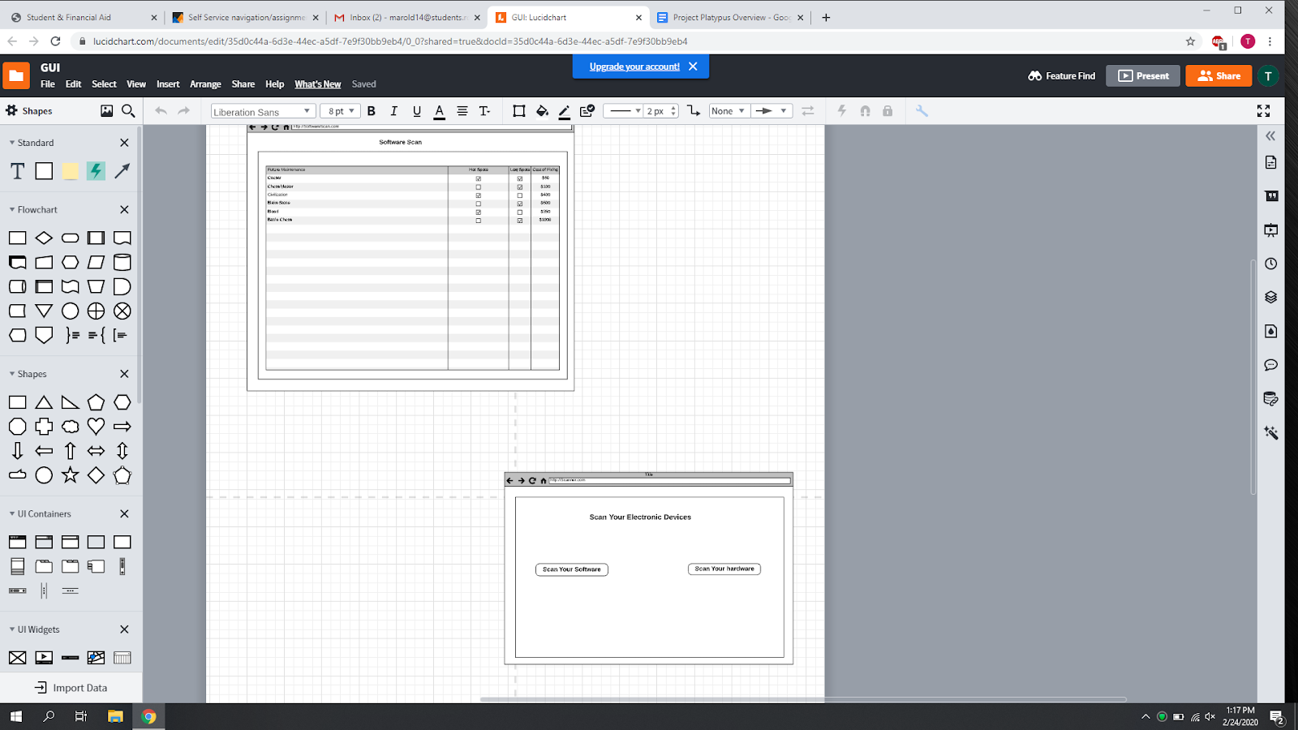

# **Business Requirements**

## ***P.L.A.T.Y.P.U.S* Business Functions**

### **Functional Requirements**

*This section identifies the Business Functional Requirements of the P.L.A.T.Y.P.U.S. system. The Business functions include:*

* *Use a security scanning tool to scan for vulnerabilities and output the data to a usable format*
* *After comparing the scan data to the specific STIGs, display the most vulnerable areas*
* *Use estimates to show the cost of software or hardware upgrades*

## ***P.L.A.T.Y.P.U.S.* Maintenance Functions**

## **Report Requirements**

# **Technical Requirements**

## **Hardware and System Software Requirements**

## *PC or Laptop.*

* *Cset*
* *Nmap*

## **Software System Interface Requirements**

*Most of Team 5 projects are faced with a major environmental requirement, the insertion of the business process solution’s functionality into an existing computing environment. Therefore, those interface requirements that are not dependent upon design should be included as part of business process requirements. By identifying these requirements early in the project, project scope, complexity and risks can be more readily managed.*

*Refer to the standards produced by the Architect and Operations groups to avoid misunderstandings concerning compliance.*

## **Commercial off-the-shelf Software**

# **Operational and Performance Requirements**

*This section contains information that can be used to calculate the total cost of ownership (TCO) for hardware software system requirements and define the Service Level Agreements (SLA). This information may be expanded in Design Documentation.*

## **Operation Mode and Availability**

*This software will be interactive via an easy to use GUI. It should be run preferably once a month, towards the end of that month.*

### **Availability**

*This program should be available at all times*

## **Capacity Requirements**

## **Storage Requirements**

*This program does not store anything on the system*

## **Facility, Co-location, Infrastructure, or Co-hosting Requirements**

## **Network or Connectivity Requirements**

*Is Internet access required? – Yes Internet is strongly required for the program to work*

*Wi-fi or Ethernet connection*

## **Security Requirements**

*As of now there are no security restrictions*

## **Post-Implementation Support Concepts**

* There wouldn’t be any changes after this program has been released, unless a team member wants to dive in even more.

# **User Acceptance Testing Requirements**

## **Categorize the Business Requirements into testing priorities and risk factors.**

## **Identify UAT Scenarios, test cases and test conditions.**

*.*

## **User Acceptance Test Approach**

## **User Acceptance Test Environment**

# **Implementation Requirements**

## **Introduction**

## **Training Requirements**

## **System Roll Out Requirements**

*.*

## **Communications Requirements**

*The* ***P.L.A.T.Y.P.U.S*** *Project Manager has ultimate responsibility for effective communications of project information. The Project Manager in concert with management will maintain communications with all field personnel impacted or affected by the implementation of the P.L.A.T.Y.P.U.S system, and all Business Area Representatives identified in Chapter 8.*

## **Operational Procedures**

## **User Documentation Requirements**

## **System Distribution Requirements**

## **Facility Readiness Requirements**

## **Built-in Help Requirements**

# **Glossary of terms**